SPRINT DELIVERY 1

TEAM ID : PNT2022TMID19437

PROJECT NAME : PERSONAL ASSISTANCE FOR SENIORS WHO ARE SELF RELIANT

CONTENTS:

1. INDEX PAGE
2. LOG IN
3. SIGN UP
   1. **INDEX PAGE**

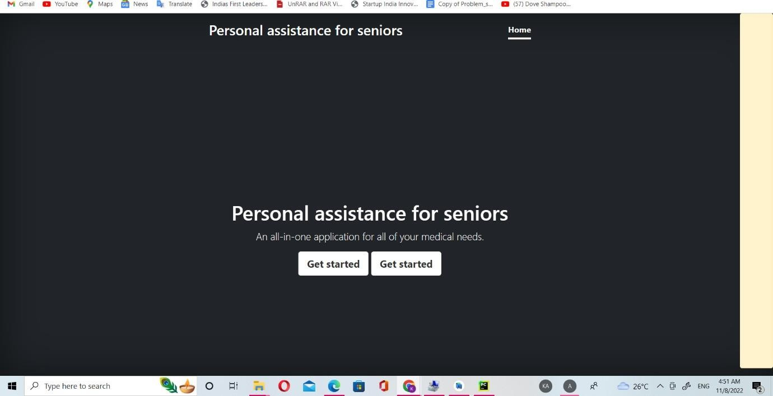

* 1. **LOGIN PAGE**

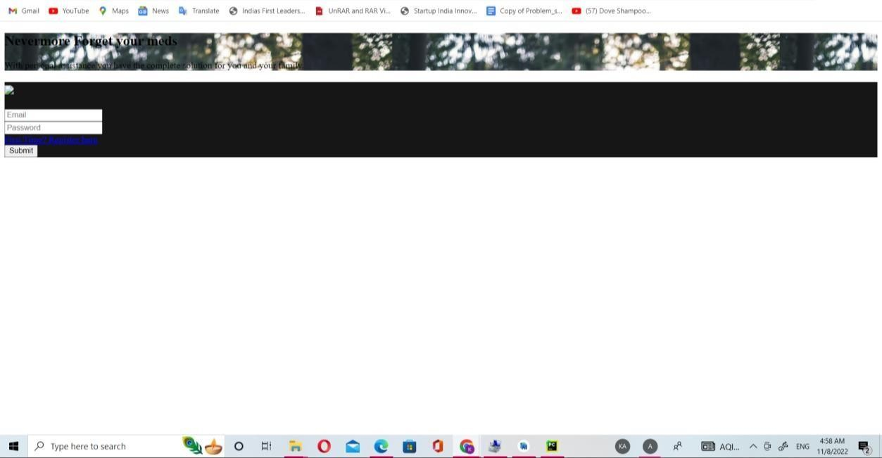

* 1. **SIGN UP PAGE**

